**Step-1:**  **BITS Approval System web portal address:** https://ipcservices.bits-pilani.ac.in/BAS/

**Step-2:**  Login to BITS Approval System using your Department/Division/Unit/Center BITS login ID and Password (Use the latest **Mozilla Firefox** OR **Google Chrome** web browser only).

**Step-3:**  On Successful login you will be redirected to **Dashboard** Page. Dashboard page will display the Current financial year approved budget of your Department/Division/Unit/Centre.

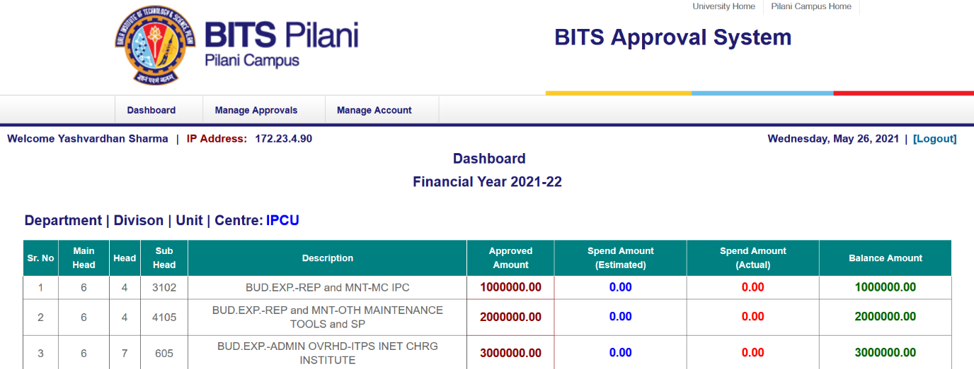

**Step-4:**  To Create Form-A, go to “**Manage Approval**” tab. Under this tab, you can create new Form-A approval request, Edit approvals, and can view the approval status.

1. **New Approval:** In this section, you can create a new approval (Form-A).
2. Click on New Approval link. Read the Instructions and Check on Checkbox and then Click on “**Continue**” button.

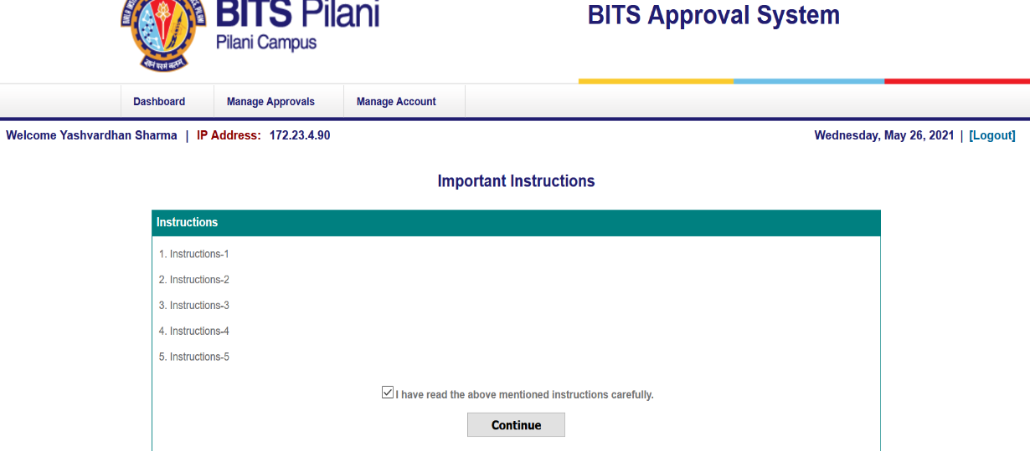

1. On Next Page, you will get the Budget details of your department. This page will display the approved budget, spend budget and available balance for individual budget heads.

Choose the appropriate budget head and Click on “**Create Form-A**” link.

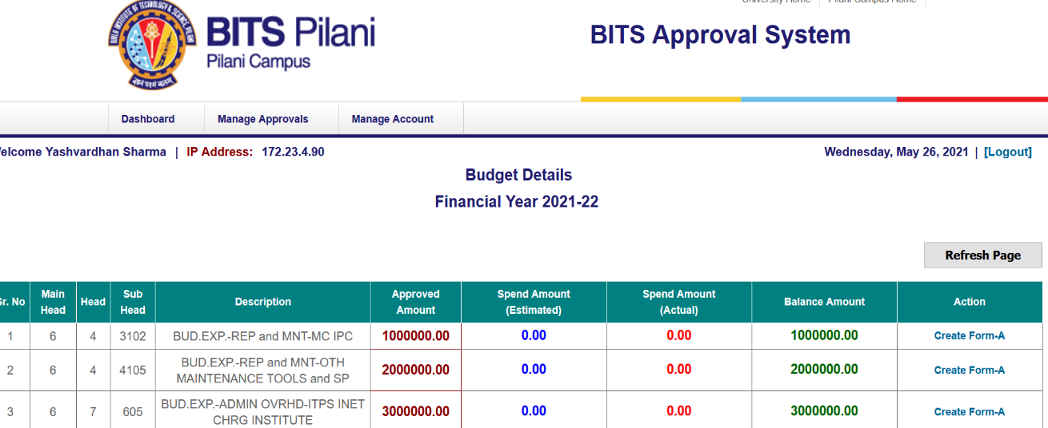

1. On Next Page, you will get the Form-A perform. Now you can enter your Form-A details.
2. You can type or copy & paste the item description in the Item description box, type item quantity (only numbers allowed) and type item cost (only numbers are allowed. Click on “Save and Add More” button to save the item details.

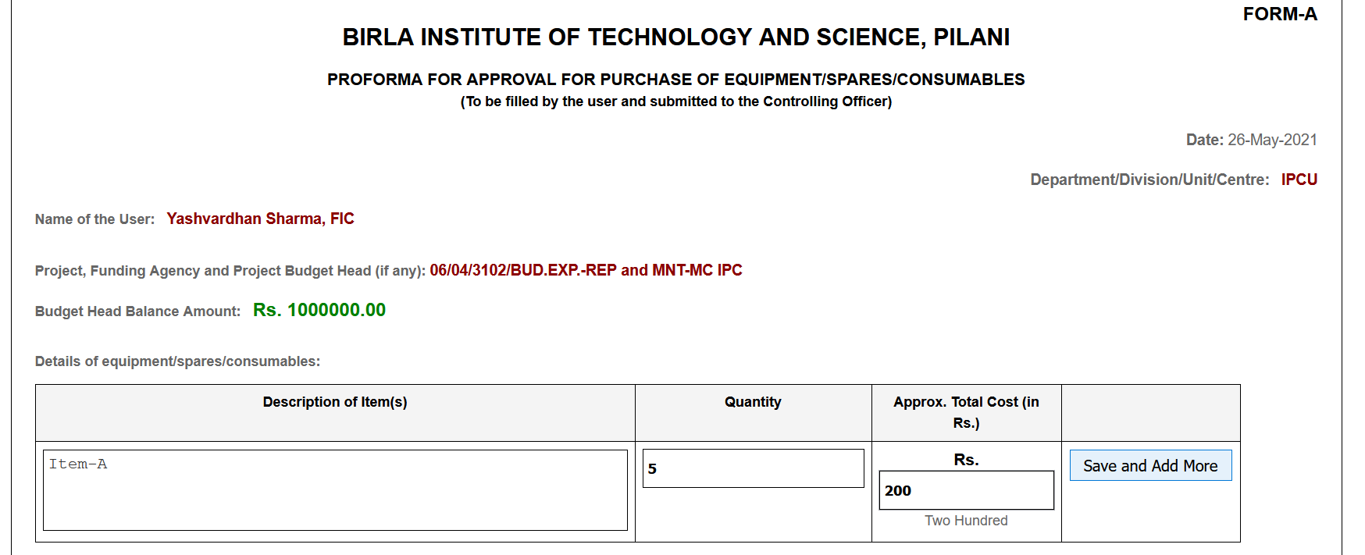

**Important Note:** Decimal values are **NOT** allowed in Quantity and Amount. Only number values are allowed.

1. Now you can see the saved item details. There is **“NO”** edit option to edit the item details. If you want to update any information for any item, simply delete the item details using “**Delete**” option and re-enter the item details.

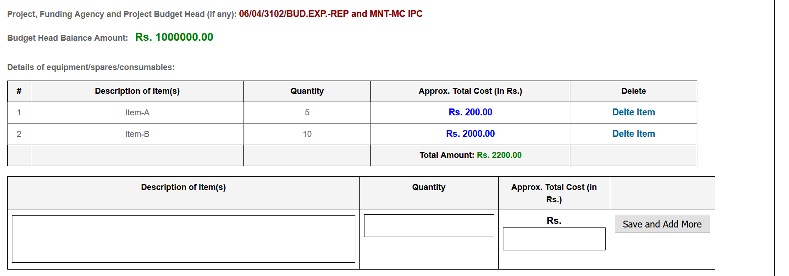

1. Type or copy & paste the Justification for your approval request.
2. Now Click on “**Save and Preview**” button to preview the Form-A.

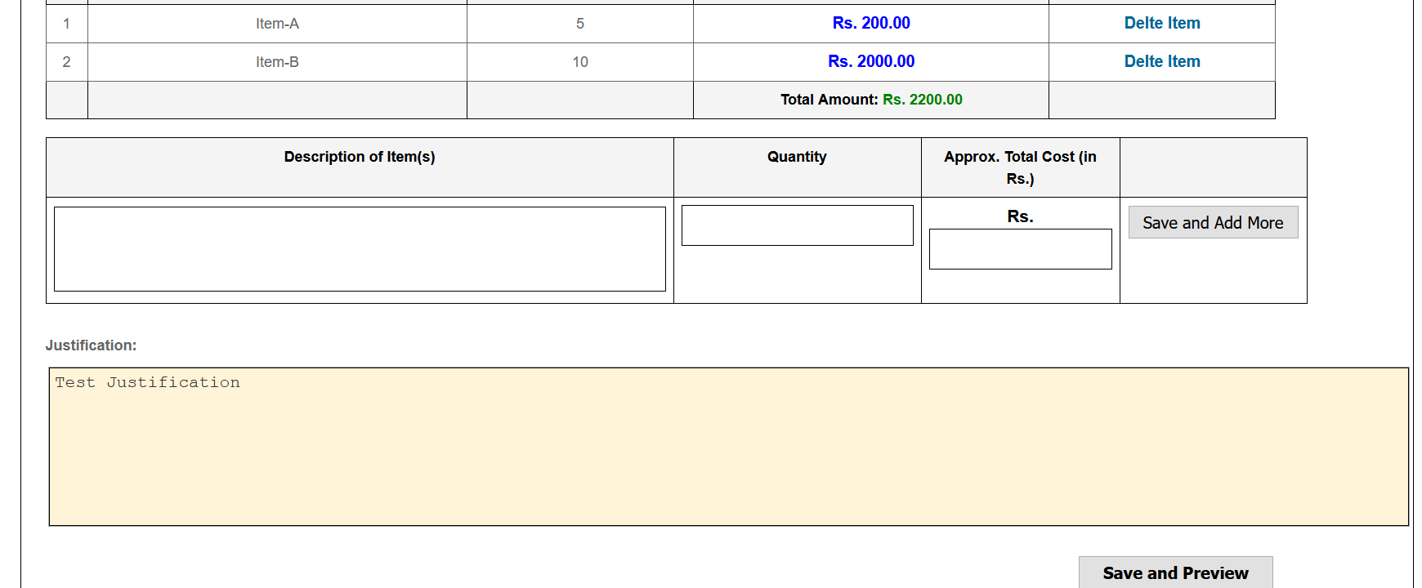

1. Now you can view Form-A complete details. Using “**Edit**” option you can edit the Form-A details before the final submission.
2. For final submission of Form-A request, enter the “**Security Code**” and click on “**Submit**” button.
3. On successful submission of the request, you will get the Confirmation page.

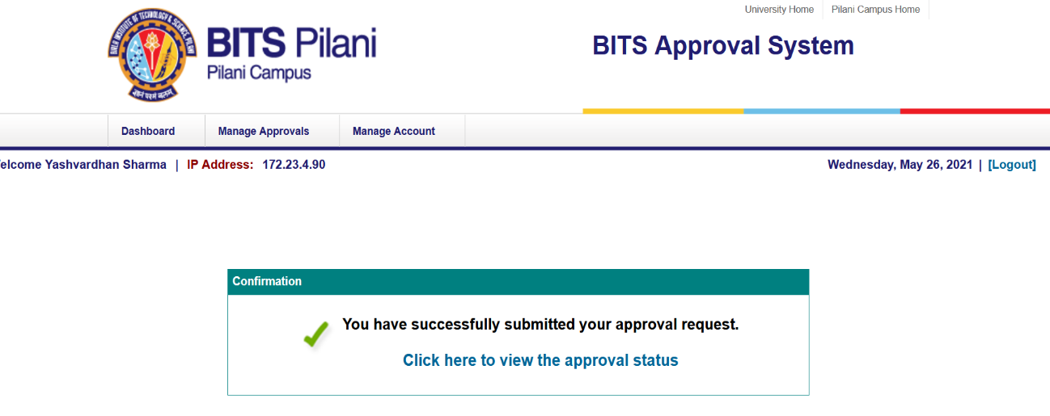

1. **View Approval Status:** In this section, you can view your approval status with all approval details.

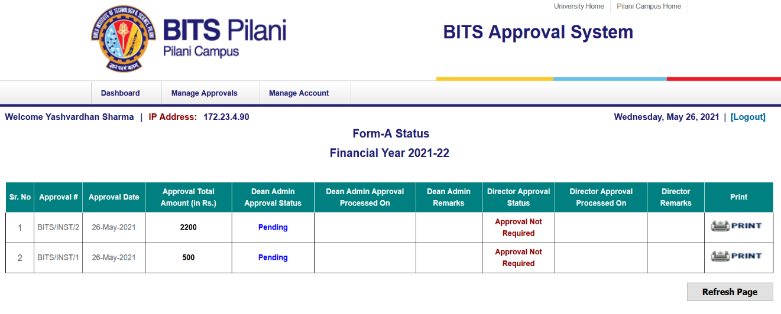

Here you can view the approval status. You will get email notification on approval **“Approved”** OR **“Not Approved”** by Dean Administration ON Director.

**Print Option:** Using print Option, you can Print the approval.

**Save as PDF File:** To Save as PDF File, click on Print Option and there you will find Save as PDF (Save to PDF) option or other PDF options.

1. **Edit Approval:** In this section, you can edit the approvals which are “**Not Approved**” by the Dean Admin or Director.

**Using this option, you can edit the item details or Justification.**

**Important Note:** You can’t change the Budget Head details in the “Edit Approval” section. Only Item details or Justification can be updated

**Step-5:**  You can Grant access of your account to another user (in case you are out of station/ on Leave). Go to “**Manage Account**” section:

1. **Delegate Account Access:** Using this option, you can grant your account access to another user.
2. Enter user BITS Email Account, user Full Name and enter the security code and click on “**Submit**” button.

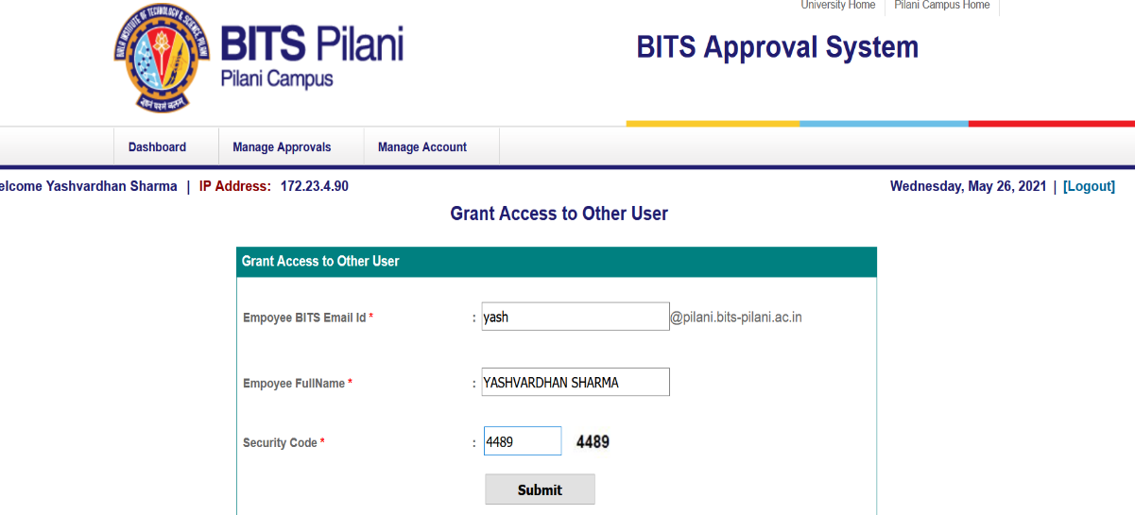

1. On successful submission, you will get the confirmation page and an email notification of login details will be sent to the user.
2. **Delete Account Access:** Using this option, you can delete the account given to the another user.

**Note: For any technical issues / login issues, please contact to SDET Unit.**